


Korea Lunar Exploration Program
DTNPL Flight Model Thermal Vacuum Test Procedure

Date: 23 Apr. 2020 | Doc. No: KPLO-D0-550-421  Issue: F.00  Total page: 35

Superseding Revised

Reviewed By:  Jae-Woon Choi Date  DTN SBC Product Assurance, Lumir |  | Prepared By:  Sun-Ku Kim Date  DTN SBC Hardware Engineer, Lumir  Dae-Soo Oh Date  DTN SBC Project Manager, Lumir
Approval Signature:  Chol-Oh Jeong Date  DTN Payload Product Assurance, ETRI |  | Jin-Ho Jo Date  DTN Payload Project Leader, ETRI  Byoung-Sun Lee Date  DTN Program Manager, ETRI

Original CDMO Release__________________

Revision History
Version | Author(s) |  | Date | Description
F.00 | Sun-ku Kim |  | 2019. 04. 23 | Initial

Revision/Change Records
Version | Date | Revision/Change Description | Pages
F.00 | 2020. 04. 23 | Initial | All

Documents Tree

Contents

1. Introduction 9
1.1. Purpose and Scope 9
1.2. Applicable Documents 9
1.2.1. ETRI Documents 9
1.2.2. Reference Documents 9
1.3. Abbreviations 9
2. Test Article 11
2.1. DTNPL Configurations 11
2.1.1. CON_PWR 11
2.1.2. CON_COMM 11
2.1.3. CON_DEBUG 12
2.2. Verification Cross Reference 13
2.3. Notification for Qualification and Acceptance Test 13
3. Test Condition 14
3.1. Test Personal 14
3.2. Precaution and Warnings 15
4. Test Setup 16
4.1. Test Facility 16
4.2. Thermal Vacuum Chamber Setup 16
4.3. Test Preparation 16
4.3.1. Control and Measuring Equipment 16
5. Test Description 18
5.1. Thermal Vacuum Test Levels 18
5.2. Temperature Profile 18
5.3. Test Parameters 19
6. Test 20
6.1. Test preparation 21
6.2. Ambient Test Before Thermal Vacuum Test 22
6.3. 1st Cycle - Hot Plateau 23
6.4. 1st Cycle - Cold Plateau 24
6.5. 2nd Cycle - Hot Plateau 25
6.6. 2nd Cycle - Cold Plateau 26
6.7. 3rd Cycle - Hot Plateau 27
6.8. 3rd Cycle – Cold Plateau 28
6.9. 4th Cycle – Hot Plateau 29
6.10. 4th Cycle – Cold Plateau 30
6.11. 5th Cycle – Hot Plateau 31
6.12. 5th Cycle – Cold Plateau 32
6.13. Back to Ambient Temperature 33
6.14. Functional Test After Thermal Vacuum Test 34
6.15. Remove DTNPL From Chamber 35
7. Test Conclusion 35

Figures

Figure 2-1 DTNPL Configurations 11
Figure 2-2 Power Connector 11
Figure 2-3 Commend Connector 12
Figure 2-4 Debug Connector 13
Figure 4-1 Thermal Vacuum Chamber Layout 16
Figure 4-2 Location of Thermal Sensors 17
Figure 5-1 Temperature Design and Test Limits 18
Figure 5-2 Timeline for Thermal Cycle Profile 19

Tables

Table 4-1 Control Thermal Sensors 17
Table 4-2 Measurement Thermal Sensors 17
Table 5-1 DTNPL Test Temperature Limits 18

Introduction

Purpose and Scope
This document defines the Acceptance level Thermal Vacuum test procedure for DTN payload FM of KPLO.
The purpose of this is to demonstrate that the DTN payload is working as expected under the required environmental conditions. During the Thermal Test a representative collection of functionality and performance test will be performed to check interfaces and hardware related functions.

Applicable Documents

ETRI Documents
 | Document Number | Document Title
AD01 | KPLO-D0-550-000 | System Requirement of DTN Payload
AD02 | KPLO-D0-550-001 | System Specification of DTN Payload
AD03 | KPLO-SP-320-002 | KPLO Environmental Design and Test Specification

Reference Documents
 | Document Number | Document Title
RD01 | MIL-STD-1540C | Test Requirements for Launch, Upper-Stage, and Space Vehicles
RD02 | PSS-01-801 | Test Requirements Specification for Space Equipment
RD03 | ECSS-E-10-03-A | ECSS Space Engineering-Testing

Abbreviations
AMS | Asynchronous Message Service
BP | Bundle Protocol
BSS | Bundle Streaming Service
CCSDS | Consultative Committee for Space Data Systems
CFDP | CCSDS File Delivery Protocol
DCC | DTN Control Center
CRC | Cyclical Redundancy Check
DMA | Direct Memory Access
DTN | Delay(Disruption) Tolerant Network
DTNPL | DTN Payload
EOD | End of Data
EOF | End of File
FW | Firm Ware
FSW | Flight Software
ION | Interplanetary Overlay Network
KDSA | Korea Deep Space Antenna
KPLO | Korea Pathfinder Lunar Orbiter
LCM | Lander Communication Model
LTP | Licklider Transmission Protocol
MOC | Mission Operation Center
OBC | On Board Computer
OBT | On Board Time
PDHU | Payload Data Handling Unit
RCM | Rover Communication Model
RFU | Reserved for Future Use
SBC | Single Board Computer
SOD | Start of Data
SOF | Start of File
SOH | Start of Head
TBC | To Be Confirmed
TBD | To Be Defined
TC | Tele-command
TCP | Transmission Control Protocol
TM | Telemetry
UART | Universal Asynchronous Receiver Transmitter
USRT | Universal Synchronous Receiver Transmitter

Test Article
The Objective of this Thermal Vacuum test is to demonstrate compliance of the DTNPL Requirements Specification [AD 03]
This test procedure shall be used for test of the DTNPL FM.
The test procedure is written such that results and other information shall be filled into it.

DTNPL Configurations
The unit under test is shown in the following figures :
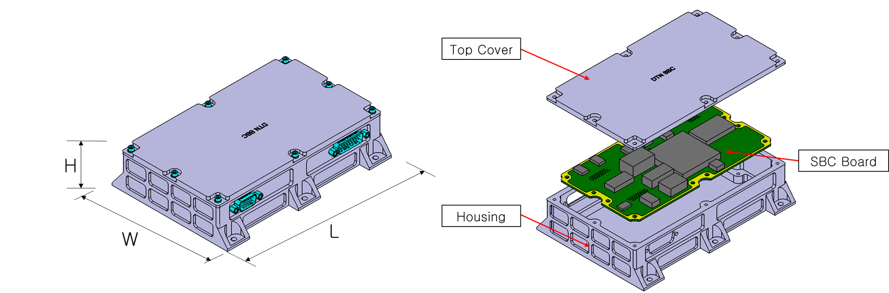
Figure 2-1 DTNPL Configurations
Dimension: 120 x 170 x 39 ㎜
Weight: 1.23 kg

CON_PWR
- Power Input (2 lines for +28V, 2 lines for RTN)
Figure 2-2 Power Connector

CON_COMM
- 1 UART for OBC
- 2 USRT for PDHU(P/R)
- 1 Bi-level Status for OBC
- 1 Bi-level Command for OBC

Figure 2-3 Commend Connector

CON_DEBUG
- 1 JTAG for Firmware Uploading
- 1 RS422 for Debugging UART
- 1 SpaceWire for Image Uploading, 40 Mbps (TBR)
- 1 GPIO for Debugging
- 1 SPI for DT10 (S/W Test Platform)
Figure 2-4 Debug Connector

Verification Cross Reference
The requirements which have to be verified by a successful performance in the test and its relevant test steps are given below:

Applicable Doc. | Requirement | Verified by Test Step | Compliance
KPLO-SP-320-002 | Environmental Design and Test Specification | All | C

Notification for Qualification and Acceptance Test
This test procedure shall be approved by the ETRI prior to performance of the test, either by signature on cover page of by performance of a dedicated Test Readiness Review(TRR).

Test Condition

Test Personal
The personnel required for the performance of the test is listed below:

Test Engineers
The test engineers are responsible for :
- Operation of measuring instrumentation, data acquisition, data handling, data recording
- Identification and compilation of data sheet
- Safety precaution for test articles
- Test personnel to be present in the test area
- The accuracy of the measured values & Data report

Test Manager
The test manager is responsible for :
- Test articles and technical aspects of the test performance
- Record the correct software version for test article and EGSE
- Examination of disturbances
- Test article Integration and handling
- Test performance
- Evaluation of test results & Providing of test reports

Quality Assurance Engineer
The QA engineer is responsible for :
- Surveillance of test equipment according to regulations as well as the test procedure
- Statement that the test articles to be tested have passed all checks before testing
- Checking the identification markings on the test articles
- Supervision of the proceeding with respect to quality assurance performance

The customer has the fight to participate or observe the test
Responsibility | Company /Dep. | Name
Test Engineer | Lumir / R&D | Sun-ku Kim
Test Manager | Lumir / R&D | Dae-Soo Oh
Quality Assurance Engineer | Lumir / PA | Seong-Woon Cho
Facility Engineer / Operator | KASI / Engineer

Precaution and Warnings
For all testing and handling, Environmental requirements concerning personnel, facilities and test equipment shall be regarded.
No special hazard exists during the test.

The following precautions apply:
- Only trained personnel are allowed to handle the test specimen.
- A test cable or breakout box shall never be connected of disconnected when the test specimen is powered.
- Correct set-up of the test equipment has to be checked carefully prior to the connection/switch-on of flight hardware, e.g. bonding, grounding, voltages, current limiters, etc.
- The test specimen shell be protected by a clean, antistatic bag all the time no activities are performed at the hardware.

Test Setup

Test Facility
The DTNPL test will be performed at the Thermal Vacuum facility. Thermal Vacuum chamber provides the anechoic chamber.

Thermal Vacuum Chamber Setup
For Thermal Cycling Test the following setup will be used:
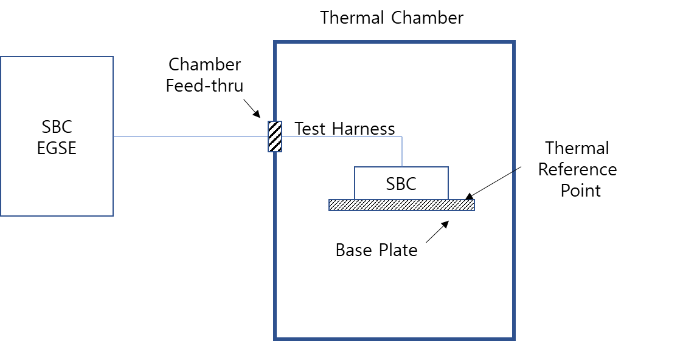
Figure 4-1 Thermal Vacuum Chamber Layout

Following Software will be used for Thermal Vacuum Test
- Software :
- Version :

Test Preparation
The test harness shall be connected from DTNPL EGSE to the DTNPL through the Thermal Vacuum Chamber feed-thru. During the test, the DTNPL shall be operated in representative manner
(i.e. data are transferred via all interfaces and stored).

Control and Measuring Equipment
The thermal plate and the DTNPL unit will be equipped with temperature sensors(Thermocouples) on the positions defined in the descriptions below. The actual sensor positions will be noted after fixing on the equipment as given in the sensor location plan at the following tables:

Table 4-1 Control Thermal Sensors
No. | Position | Remark
C1 | Base Plate | Defined by Test Engineer
C2 | Base Plate (optional) | Defined by Test Engineer

Table 4-2 Measurement Thermal Sensors
No | Position | Remark
T1 | DTNPL Top Cover
T2 | DTNPL Case Side

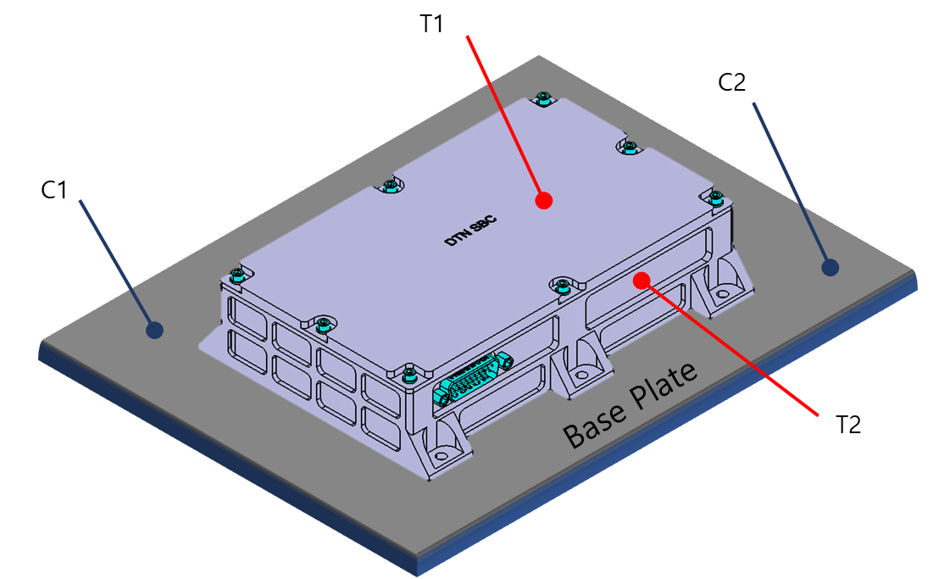
Figure 4-2 Location of Thermal Sensors

Test Description

Thermal Vacuum Test Levels
The nominal sequence of the thermal cycles is depicted in and temperature range for tests are summarized in

Table 5-1 DTNPL Test Temperature Limits
 | Temperature Limits (degree C)
Equipment | Proto-flight (Operating) Range |  | Cold  Turn-On | Acceptance  (Operating)  Range |  | Survival  (Non-Operating)  Range
 | Min | Max |  | Min | Max | Min | Max
DTNE_DTNPL | -30 | 60 | -30 | -20 | 50 | -35 | 70

Figure 5-1 Temperature Design and Test Limits

Temperature Profile
The DTNPL shall be subjected to temperature cycles as described in the following figure. DTNPL operation over the range of temperatures shall be demonstrated at specific points during the thermal cycling test according to the following figure.

Figure 5-2 Timeline for Thermal Cycle Profile

Test Parameters
The following test parameters shall apply:
- TN min/max : -35℃ / 70℃
- TA min/max : -25℃ / 55℃
- TS: -30℃
- Tambient : ambient
- ts : minimum 1hr
- tA : minimum 2hr
- dT/dt ≤ 2℃
- Pressure ≤ 1 x 10⁻⁵
- Number of cycles : 5 cycle

Test
The DTNPL shall have a full functional test performed at ambient temperature prior to beginning the thermal cycling test. Thermal soak duration shall be at least 6 hours at the hot temperatures and 6 hours at
the cold temperatures during the first and last cycle (Figure 5-2). Intermediate cycles shall give at least 1 hour soak at the hot and cold temperatures. During the thermal soak, the unit shall be turned off until the temperature stabilizes and turn on. Remaining on until the next soak period off on sequence. Measurement of thermal soak duration shall begin at the time of unit turn on (Figure 5-2).
Functional tests shall be conducted after the DTNPL temperature have stabilized at hot and cold temperatures during the first and last thermal cycle, and after return to ambient. During the remainder of the test, electrical and electronic units, including all redundant circuits and paths, shall be cycled through various operation modes.
DTNPL shall meet their performance requirements within specification over the maximum expected temperature range extended at both temperatures by 10°C. The final thermal cycle should employ a sufficiently slow temperature transition to permit a complete functional check to be repeated at essentially all temperatures.
Moisture condensation in side of DTNPL shall be prevented.

Test preparation

Start Date : ________________________ / Time : ________________________

(1) | Fill out test environment conditions | Pass / Fail | Sign
(2) | Fill out test personnel | Pass / Fail | Sign
(3) | Check test articles and fill out, check, and sign Test Article list above | Pass / Fail | Sign
(4) | Check test equipment and fill out, check, Test Equipment list above setup complete | Pass / Fail | Sign
(5) | Power off for each test article and test equipment switched off Install DTNPL in Thermal Vacuum Cycling chamber | Pass / Fail | Sign
(6) | Mount DTNPL onto the base plate by fixing of screws. | Pass / Fail | Sign
(7) | Attach temperature sensors according to chapter 4.4.1 | Pass / Fail | Sign
(8) | Check that connector savers installed on all used interfaces | Pass / Fail | Sign
(9) | Connect harness to DTNPL and connect harness to chamber feed- through | Pass / Fail | Sign
(10) | Take pictures of the mounted DTNPL when ready for thermal cycling test | Pass / Fail | Sign
(11) | Start recording temperature measurement points and chamber temperature continuously | Pass / Fail | Sign
(12) | Correlate time, Temperature and test results exactly | Pass / Fail | Sign

End Date: / Time:

Test Engineer: (Signature)

Ambient Test Before Thermal Vacuum Test

Start Date: / Time:
Temperature: ℃ (19 ~ 25℃)
Humidity: % (35 ~ 55℃)

With feed assembly in the thermal chamber, the functional test should be performed at the ambient condition in accordance with the following sequence and record the test results per the indicated method.

 | Test Description | Nominal Value | Actual Value
(1) | Measure input voltage | Under 0.5A
(2) | Measure input voltage | 28V
(3) | Perform test ‘STP’ | PASS

End Date: / Time:

Test Engineer: (Signature)

1st Cycle - Hot Plateau

Start Date: / Time:

- Increase the temperature in the T/V chamber (Ambient to +70℃)

 | Temperature
 | C1 | C2 | T1 | T2
Start
End

- After maintaining at least 1 hour at 70℃, then start the temperature drop

End Date: / Time:

Test Engineer: (Signature)

1st Cycle - Cold Plateau

Start Date: / Time:

- Start thermal transition Temperature(70℃ to -35℃)

 | Temperature
 | C1 | C2 | T1 | T2
Start
End

- Maintain at least 1 hour at -35℃, and then increase the temperature by -30℃.
-30℃ arrival time :
 | Temperature
 | C1 | C2 | T1 | T2
Start
End

- Verification ON/OFF switching
On/Off Normal state ? :

- Maintain at least 1hour with power off state at -30℃

- DTN Power On
DTN P/S Parameter Value : __________V___________A

End Date: / Time:

Test Engineer: (Signature)

2nd Cycle - Hot Plateau

Start Date: / Time:

- Start thermal transition (-30℃ to 55℃)

 | Temperature
 | C1 | C2 | T1 | T2
Start
End

- Perform DTNPL test and fill out the table below

 | Test Description | Nominal Value | Actual Value
(1) | Measure input voltage | Under 0.5A
(2) | Measure input voltage | 28V
(3) | Perform test ‘STP’ | PASS

- Verification OFF/ON switching
Off/On Normal state ? :

- Hold temperature for at least 1 hour

End Date: / Time:

Test Engineer: (Signature)

2nd Cycle - Cold Plateau
Start Date: / Time:

- Start thermal transition (55℃ to -25℃)

 | Temperature
 | C1 | C2 | T1 | T2
Start
End

- Perform DTNPL test and fill out the table below.

 | Test Description | Nominal Value | Actual Value
(1) | Measure input voltage | Under 0.5A
(2) | Measure input voltage | 28V
(3) | Perform test ‘STP’ | PASS

- Hold temperature for at least 1 hours.

End Date: / Time:

Test Engineer: (Signature)

3rd Cycle - Hot Plateau

Start Date: / Time:

- Start thermal transition (-25℃ to 55℃)

 | Temperature
 | C1 | C2 | T1 | T2
Start
End

- Perform DTNPL test and fill out the table below

 | Test Description | Nominal Value | Actual Value
(1) | Measure input voltage | Under 0.5A
(2) | Measure input voltage | 28V
(3) | Perform test ‘STP’ | PASS

- Hold temperature for at least 1 hour

End Date: / Time:

Test Engineer: (Signature)

3rd Cycle – Cold Plateau

Start Date: / Time:

- Start thermal transition (55℃ to -25℃)

 | Temperature
 | C1 | C2 | T1 | T2
Start
End

- Perform DTNPL test and fill out the table below.

 | Test Description | Nominal Value | Actual Value
(1) | Measure input voltage | Under 0.5A
(2) | Measure input voltage | 28V
(3) | Perform test ‘STP’ | PASS

- Hold temperature for at least 1 hours.

End Date: / Time:

Test Engineer: (Signature)

4th Cycle – Hot Plateau

Start Date: / Time:

- Start thermal transition (-25℃ to 55℃)

 | Temperature
 | C1 | C2 | T1 | T2
Start
End

- Perform DTNPL test and fill out the table below

 | Test Description | Nominal Value | Actual Value
(1) | Measure input voltage | Under 0.5A
(2) | Measure input voltage | 28V
(3) | Perform test ‘STP’ | PASS

- Hold temperature for at least 1 hour

End Date: / Time:

Test Engineer: (Signature)

4th Cycle – Cold Plateau

Start Date: / Time:

- Start thermal transition (55℃ to -25℃)

 | Temperature
 | C1 | C2 | T1 | T2
Start
End

- Perform DTNPL test and fill out the table below.

 | Test Description | Nominal Value | Actual Value
(1) | Measure input voltage | Under 0.5A
(2) | Measure input voltage | 28V
(3) | Perform test ‘STP’ | PASS

- Hold temperature for at least 1 hours.

End Date: / Time:

Test Engineer: (Signature)

5th Cycle – Hot Plateau

Start Date: / Time:

- Start thermal transition (-25℃ to 55℃)

 | Temperature
 | C1 | C2 | T1 | T2
Start
End

- Perform DTNPL test and fill out the table below

 | Test Description | Nominal Value | Actual Value
(1) | Measure input voltage | Under 0.5A
(2) | Measure input voltage | 28V
(3) | Perform test ‘STP’ | PASS

- Hold temperature for at least 2 hour

End Date: / Time:

Test Engineer: (Signature)

5th Cycle – Cold Plateau

Start Date: / Time:

- Start thermal transition (55℃ to -25℃)

 | Temperature
 | C1 | C2 | T1 | T2
Start
End

- Perform DTNPL test and fill out the table below.

 | Test Description | Nominal Value | Actual Value
(1) | Measure input voltage | Under 0.5A
(2) | Measure input voltage | 28V
(3) | Perform test ‘STP’ | PASS

- Hold temperature for at least 2 hours.

End Date: / Time:

Test Engineer: (Signature)

Back to Ambient Temperature

Start Date: / Time:

- Start thermal transition +25℃.

 | Temperature
 | C1 | C2 | T1 | T2
Start
End

End Date: / Time:

Test Engineer: (Signature)

Functional Test After Thermal Vacuum Test

Start Date: / Time:

- Perform DTNPL test and fill out the table below

 | Test Description | Nominal Value | Actual Value
(1) | Measure input voltage | Under 0.5A
(2) | Measure input voltage | 28V
(3) | Perform test ‘STP’ | PASS

- Switch DTNPL off.
Turn off time:

- Thermal Vacuum chamber vacuum release start

- When the Thermal Vacuum level returns to the default, Stop recording chamber data

End Date: / Time:

Test Engineer: (Signature)

Remove DTNPL From Chamber

Start Date: / Time:

- Disconnect Test Harness from DTNPL EGSE and chamber feed-through.

- Disconnect TC Harness from DTNPL EGSE and chamber feed-through.

- Remove temperature sensors.

- Dismount DTNPL Base plate fixations.

- Remove DTNPL from Chamber.

End Date: / Time:

Test Engineer: (Signature)

Test Conclusion
The PA shall review the test data for acceptance of the thermal Vacuum test.
The following sign off is verification that the test article has satisfactorily passed thermal Cycling test.

PA: Date:

